✴

|  |  |
| --- | --- |
| TEAM ID | PNT2022TMID17579 |
| DATE | 11 NOVEMBER 2022 |
| PROJECT TITLE | SMARTFARMER - IOT ENABLED SMART FARMING APPLICATION |

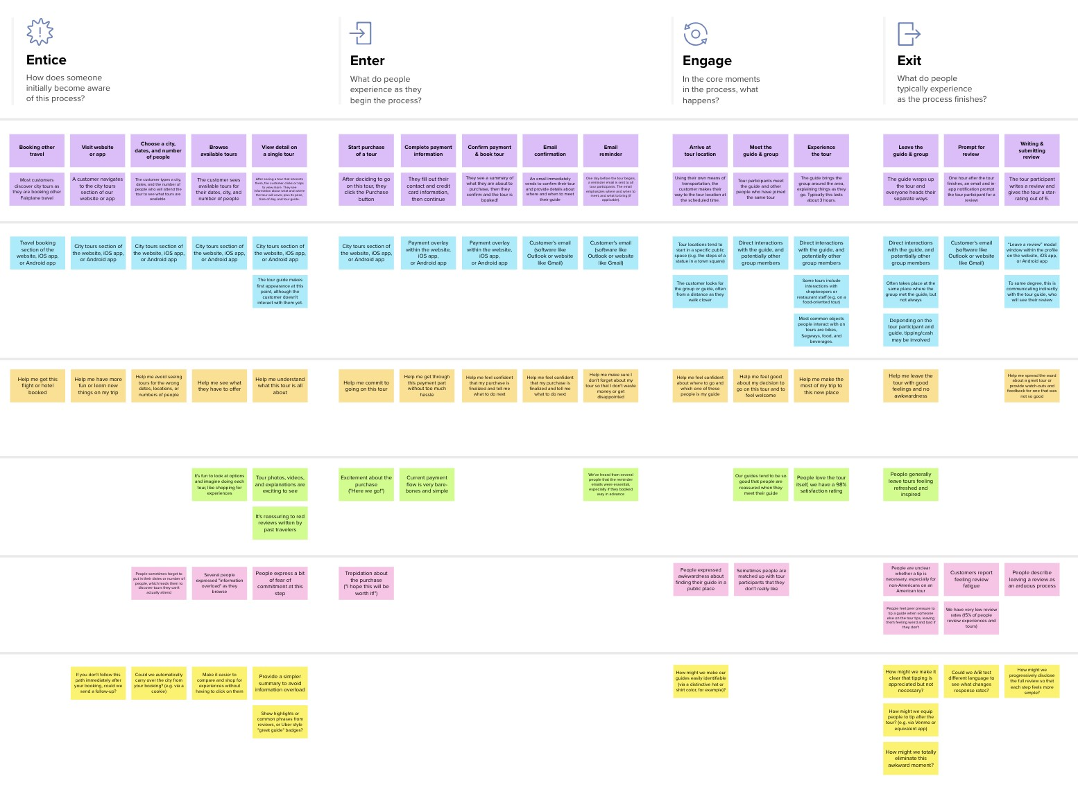

**Template**

**Document an existing experience**

**TIP**

As you add steps to the experience, move each these “Five Es” the left or right depending on the scenario you are documenting.

Narrow your focus to a specific scenario or process within an existing product or service. In the **Steps** row, document the step-by-step process someone typically experiences, then add detail to each of the other rows.

Customer experience journey map

|  |  |  |  |  |  |
| --- | --- | --- | --- | --- | --- |
| **SCENARIO**  **Browsing, booking, attending, and rating a local city tour** | **Entice**  How does someone initially become aware of this process? | **Enter**  What do people experience as they begin the process? | **Engage**  In the core moments in the process, what happens? | **Exit**  What do people typically experience  as the process finishes? | **Extend**  What happens after the experience is over? |
| **Steps**  What does the person (or group) typically experience? | **Opening the app Details of sensor Motor control**  **data**  **Visual treat is present Data is represented Providing button in and widgets are for filling color in a switch style to arranged in position bar or numeric value control the motor**  **for better experience for better**  **understanding** | Information about **More about sensor**  the land **data**  **Get to know about Click to know in**  **the land detail about it** | **Detailed information Remote access**  **Detailed information**  **about the land and Ability to control the weather which helps motor**  **to plan efficiently** | **Satisfied**  **Since the work is completed in an easier way** | **Send alerts**  **Remainder to turn off the motor** |
| **Interactions**  What interactions do they have at each step along the way?  **People:** Who do they see or talk to?  **Places:** Where are they?  **Things:** What digital touchpoints or physical objects would they use? | **Interaction with widgets for more information** | **Interaction with data** | **Interaction with switch to control the motor** | **Interaction with exit buttom** |  |
| **Goals & motivations**  At each step, what is a person’s primary goal or motivation? (“Help me...” or “Help me avoid...”) | **Current situation in the land** | **What can be done in Think about the next**  **the land step** | **To water plants in To turn ON and OFF**  **correct interval** |  |  |
| **Positive moments**  What steps does a typical person find enjoyable, productive, fun, motivating, delightful, or exciting? | **Productive for users Work is easier for the users** |  | **Feels good because the work is done correctly** | **They find their work easy and enjoyable** |  |
| **Negative moments**  What steps does a typical person find frustrating, confusing, angering, costly, or time-consuming? | **Frustration in seeing samething** | **Confusion because of different ideas** | **Need to turn off the motor in app manually** |  |  |
| **Areas of opportunity**  How might we make each step better? What ideas do we have? What have others suggested? | **Alerting to open the app every 2-4 hours to know about the information** |  | **Use of timer for better experience** |  |  |

Use this framework to better understand customer needs, motivations, and obstacles by illustrating a key scenario or process from start to finish.



When possible, use this map to document and summarize interviews and observations with real people rather than relying on your hunches or assumptions.

Created in partnership with



[**Share template feedback**](https://muralco.typeform.com/to/CiqaHVat?typeform-source=app.mural.co)



**Need some inspiration?**



See a finished version of this template to kickstart your work.

[**Open example**](https://app.mural.co/template/f59f644b-b4b4-47b5-9ed6-3a8c71ceb612/896b31fe-5597-40ef-9b06-3811a1a45ace)